**Module 5(HTML 5)**

1. **What are the new tags added in HTML5?**

**Ans:** HTML5 is an upgraded version of HTML 4.01. New elements are added in HTML5 to write easy and fast code to create complex, dynamic, engaging, and effective websites. These new elements add advanced functional features, improvised page layouts, and other improvements. The commonly used new HTML5 tags are <figure>, <article>, <header>, <main>, <footer>, <nav>, and <section>.

1. **How to embed audio and video in a webpage?**

**Ans:** To embed audio in HTML, we use the <audio> tag. Before HTML5, audio cannot be added to web pages in the Internet Explorer era.

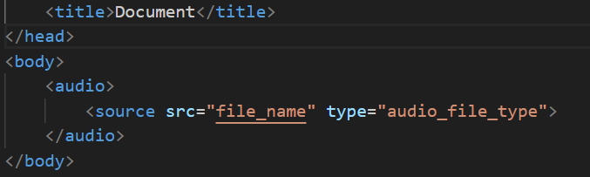

To embed video in HTML, we use the <video> tag. It contains one or more video sources at a time using <source> tag

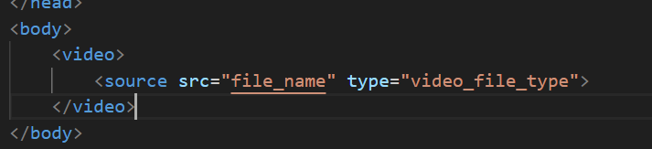

1. **Semantic element in HTML5?**

**Ans:** A semantic element clearly describes its meaning to both the browser and the developer.

Semantic elements = elements with a meaning.

In HTML there are some semantic elements that can be used to define different parts of a web page:

* <article>
* <aside>
* <details>
* <figcaption>
* <figure>
* <footer>
* <header>
* <main>
* <mark>
* <nav>
* <section>
* <summary>
* <time>

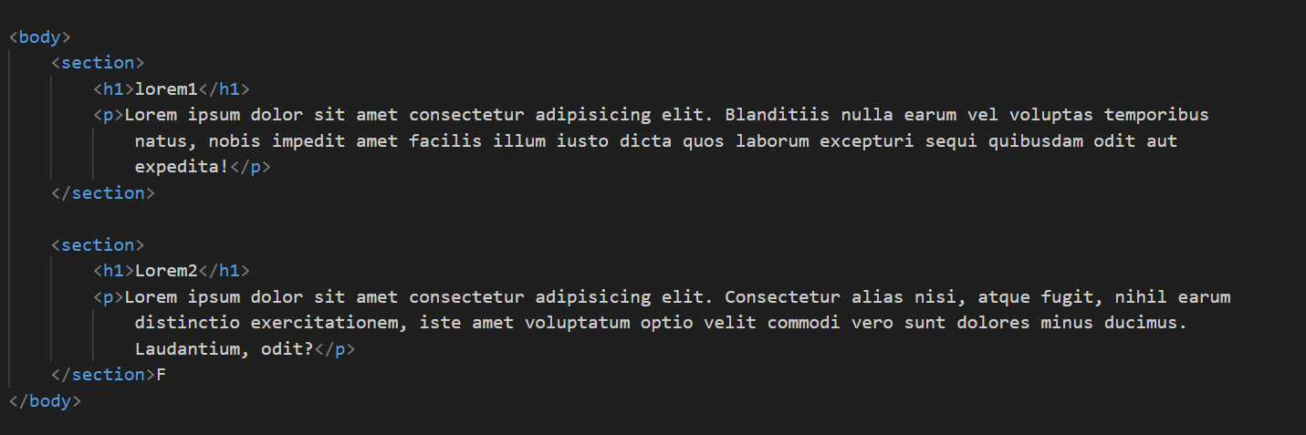

1. **Canvas and SVG tags**

**Ans: SVG :**

* SVG stands for Scalable Vector Graphics
* SVG is used to define vector-based graphics for the Web
* SVG defines graphics in XML format
* Each element and attribute in SVG files can be animated
* SVG integrates with other standards, such as CSS, DOM, XSL and JavaScript

The HTML <svg> element is a container for SVG graphics.

SVG has several methods for drawing paths, rectangles, circles, polygons, text, and much more.

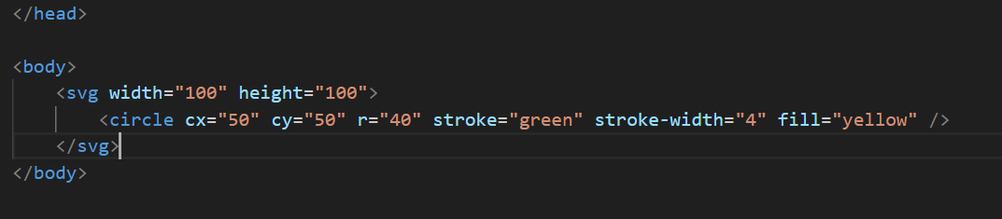

**Canvas:**

The Canvas element is used to draw graphics on the fly, via scripting. The element is only a container for graphics. Canvas has several methods for drawing paths, boxes, circles, text, and adding images.

